**Understand AI-related terms**

Dated 26/06/2023

## Data science

Data science is a discipline that focuses on the processing and analysis of data; applying statistical techniques to uncover and visualize relationships and patterns in the data, and defining experimental models that help explore those patterns.

## Machine learning

Machine learning is a subset of data science that deals with the training and validation of predictive models. Typically, a data scientist prepares the data and then uses it to train a model based on an algorithm that exploits the relationships between the features in the data to predict values for unknown labels.

## Artificial intelligence

Artificial intelligence usually (but not always) builds on machine learning to create software that emulates one or more characteristics of human intelligence.

# Understand considerations for AI Engineers

Increasingly, software solutions include AI features; so software engineers need to know how to integrate AI capabilities into their applications and services.

The advances made in machine learning, together with the increased availability of large volumes of data and powerful compute on which to process it and train predictive models, has led to the availability of prepackaged software services that encapsulate AI capabilities. Software engineers can take advantage of these services to create applications and agents that use the underlying AI functionality, using them as building blocks to create intelligent solutions.

This means that software engineers can apply their existing skills in programming, testing, working with source control systems, and packaging applications for

## Model training and inferencing

Many AI systems rely on predictive models that must be trained using sample data. The training process analyzes the data and determines relationships between the features in the data (the data values that will generally be present in new observations) and the label (the value that the model is being trained to predict).

After the model has been trained, you can submit new data that includes known feature values and have the model predict the most likely label. Using the model to make predictions is referred to as inferencing.

## Probability and confidence scores

A well-trained machine learning model can be accurate, but no predictive model is infallible. The predictions made by machine learning models are based on probability, and while software engineers don't require a deep mathematical understanding of probability theory, it's important to understand that predictions reflect statistical likelihood, not absolute truth. In most cases, predictions have an associated confidence score that reflects the probability on which the prediction is being made. Software developers should make use of confidence score values to evaluate predictions and apply appropriate thresholds to optimize application reliability and mitigate the risk of predictions that may be made based on marginal probabilities.

## Responsible AI and ethics

It's important for software engineers to consider the impact of their software on users, and society in general; including ethical considerations about its use. When the application is imbued with artificial intelligence, these considerations are particularly important due to the nature of how AI systems work and inform decisions; often based on probabilistic models, which are in turn dependent on the data with which they were trained.

# Understand considerations for responsible AI

## Fairness

## Reliability and safety

## Privacy and security

## Inclusiveness

## Transparency

## Accountability

# Understand capabilities of Azure Machine Learning

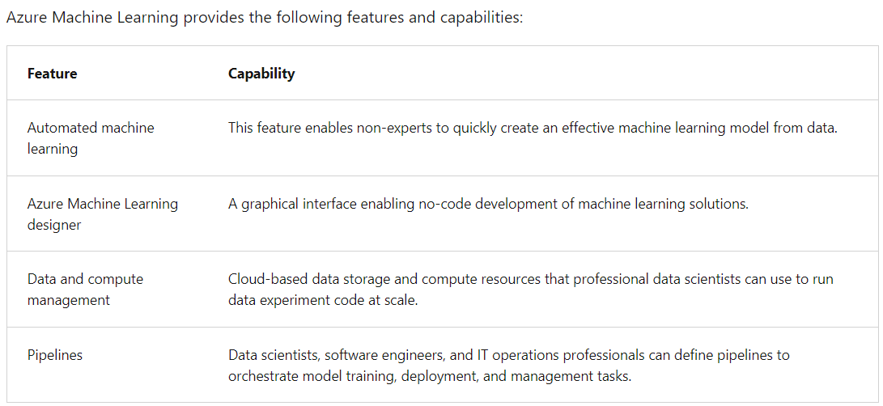Microsoft Azure provides the **Azure Machine Learning** service - a cloud-based platform for running experiments at scale to train predictive models from data, and publish the trained models as services.

# Understand capabilities of Azure Cognitive Services

**Azure Cognitive Services** are cloud-based services that encapsulate AI capabilities. Rather than a single product, you should think of Azure Cognitive Services as a set of individual services that you can use as building blocks to compose sophisticated, intelligent applications.

## **Applied AI Services**

* **Azure Form Recognizer** - an optical character recognition (OCR) solution that can extract semantic meaning from forms, such as invoices, receipts, and others.
* **Azure Metrics Advisor** - A service built on the Anomaly Detector cognitive service that simplifies real-time monitoring and response to critical metrics.
* **Azure Video Analyzer for Media** - A comprehensive video analysts solution build on the Video Indexer cognitive service.
* **Azure Immersive Reader** - A reading solution that supports people of all ages and abilities.
* **Azure Bot Service** - A cloud service for delivering conversational AI solutions, or *bots*.
* **Azure Cognitive Search** - A cloud-scale search solution that uses cognitive services to extract insights from data and documents.

# Understand capabilities of the Azure Bot Service

# The Azure Bot Service is an Applied AI service for developing and delivering bot solutions that support conversational interactions across multiple *channels*, such as web chat, email, Microsoft Teams, and others.

# Understand capabilities of Azure Cognitive Search

# Searching for information is a common requirement in many applications, from dedicated *search engine* web sites to mobile apps that can find context-appropriate information based on where you are and what you want to accomplish.

**Azure Cognitive Search** is an Applied AI Service that enables you to ingest and index data from various sources, and search the index to find, filter, and sort information extracted from the source data.

**Summary**

In this module, you learned how to:

* Define artificial intelligence
* Understand AI-related terms
* Understand considerations for AI Engineers
* Understand considerations for responsible AI
* Understand capabilities of Azure Machine Learning
* Understand capabilities of Azure Cognitive Services
* Understand capabilities of the Azure Bot Service
* Understand capabilities of Azure Cognitive Search